NAME: NAVODITAA A.R
ROLL NO: 241901071

EXERCISE 1A
WINDOWS FUNDAMENTALS 1
AIM:
To understand the fundamentals of the Windows operating system, including the Windows desktop, NTFS file system, User Account Control (UAC), Control Panel, and other essential features.

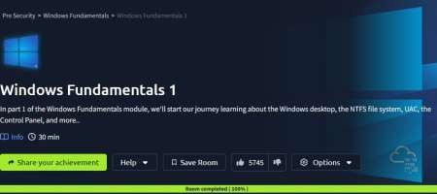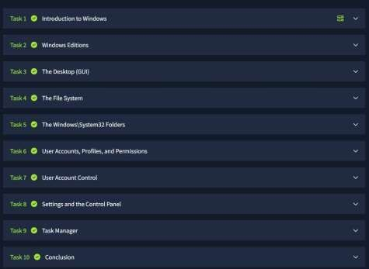

RESULT:
Successfully gained an understanding of the Windows desktop environment, NTFS file system, User Account Control (UAC), Control Panel, and other fundamental Windows features.

EXERCISE 1B
WINDOWS FUNDAMENTALS 2 AIM:
To explore advanced Windows functionalities, including System Configuration, User Account Control (UAC) settings, Resource Monitoring, and the Windows Registry, to enhance system management and troubleshooting skills.
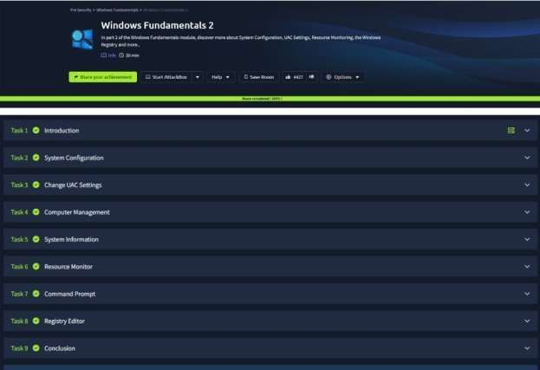

RESULT:
Successfully gained knowledge of System Configuration, adjusted UAC settings, monitored system resources, and understood the structure and importance of the Windows Registry.

EXERCISE 1C
WINDOWS FUNDAMENTALS 3 AIM:
To understand and utilize built-in Microsoft security tools such as Windows Updates, Windows Security, and BitLocker to enhance the security and integrity of a Windows system.

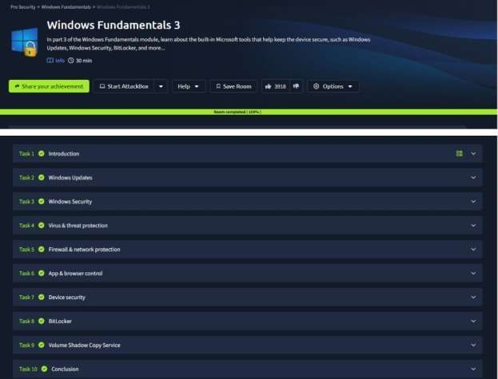

RESULT:
Successfully learned how to configure and manage Windows security features, ensuring system protection through updates, antivirus measures, and encryption mechanisms.

